PREPARATION OF PAPERS FO INTERNATIONAL REVIEW FOR HUMAN AND NATURAL SCIENCES
FIRST A. AUTHOR¹, SECOND B. AUTHOR²
DOI: https://doi.org/10.00000/IRHNS.0000000.2025.01.01
- Armed forces academy of General M.R.Štefanik, Department of Social Sciences and Languages,
Liptovský Mikuláš (SK)
- Armed forces academy of General M.R.Štefanik, Department of Social Sciences and Languages, Liptovský Mikuláš (SK)
Contact: PhDr. A Author1, PhD., MBA - a.email@ua.sk; mjr. Ing., Mgr. B. Author2 - juraj.pagacik@aos.sk

Corresponding author: First A. Author (e-mail: author@boulder.nist.gov).

This paragraph of the first footnote will contain support information, including sponsor and financial support acknowledgment. For example, “This work was supported in part by the U.S. Depart¬ment of Com¬merce under Grant BS123456.”

Abstract:
A single paragraph of about 200 words maximum. For research articles, abstracts should give a pertinent overview of the work. We strongly encourage authors to use the following style of structured abstracts, but without headings: (1) Background: Place the question addressed in a broad context and highlight the purpose of the study; (2) Methods: briefly describe the main methods or treatments applied; (3) Results: sum-marize the article’s main findings; (4) Conclusions: indicate the main conclusions or interpretations. The abstract should be an objective representation of the article and it must not contain results that are not presented and substantiated in the main text and should not exaggerate the main conclusions. The abstract must summarize the paper content and should have a reasonable number of words – 175-200 is an optimum number.

Keywords: keyword 1; keyword 2; keyword 3 (List three to ten pertinent keywords specific to the article yet reasonably common within the subject discipline.)

Introduction
The introduction should briefly place the study in a broad context and highlight why it is important. It should define the purpose of the work and its significance. The current state of the research field should be carefully reviewed and key publications cited. Please highlight controversial and diverging hypotheses when necessary. Finally, briefly mention the main aim of the work and highlight the principal conclusions. As far as possible, please keep the introduction comprehensible to scientists outside your particular field of research.

Materials and Methods
The authors should submit camera-ready paper in MS Word format. Leave 30,2 mm at the top, 19,0 mm at the bottom, and 15,0 mm margins at left and right 20 mm. The camera-ready paper size should be no more than 15 pages without authors photos and CVs. Please, don’t use numbering pages in your papers.
The figures and tables must be numbered, have a self-contained caption. Figure captions should be below the figures; table captions should be above the tables. Also, avoid placing figures and tables before their first mention in the text.

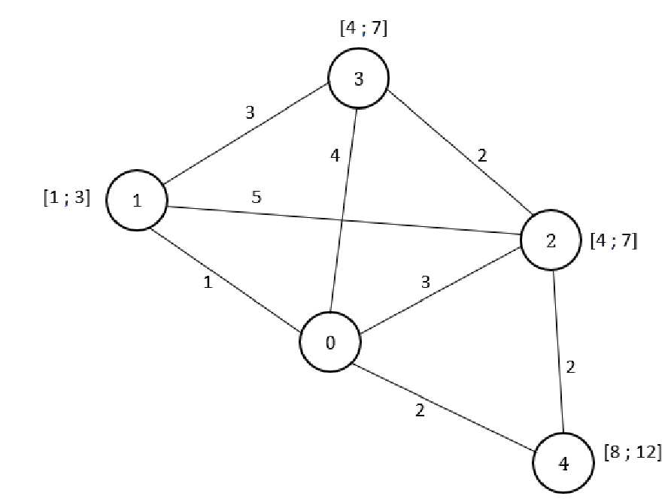
Fig. 1 Example of a figure.
The text of figure captions should be 9 points high. Use spacing of 6 points before and after. Leave one line after the tables unless a section title follows. Table captions and figure captions should be left. Leave one blank line before the caption of the table. Do not indent the captions. Do not use characters smaller than 9 point in figures.
All the figures, graphs and photographs should be numbered and referred in the main text. Use the abbreviation “Fig.” even at the beginning of a sentence. The text in the figures may be Times New Roman. Do not use abbreviations in the titles unless they are unavoidable. Font size in tables is 9 pt.

Table 1 Example of a table
The observed statistical data and the results of the Poisson probability distribution
x_{i} | n_{i} | x_{i} * n_{i} | p (x_{i}) | f (x_{i}) | χ2
0 | 17 | 0 | 0,19 | 23,17 | 1,64
1 | 49 | 49 | 0,32 | 38,30 | 2,99
2 | 32 | 64 | 0,26 | 31,65 | 0,00
3 | 11 | 33 | 0,14 | 17,44 | 2,38
4 | 7 | 28 | 0,06 | 7,21 | 0,01
5 | 4 | 20 | 0,02 | 2,38 | 1,10
6 | 1 | 6 | 0,01 | 0,66 | 0,18
Total | 121 | 200 | 1,00 |  | 8,30
Equations should be placed in separate lines and numbered. Please use separate table's cells to place an equation and its number. Do not use any equations inside of paragraph. The numbers should be within brackets and right aligned. Please set in Microsoft Equation following fonts: Regular – 11 pt, Large index – 7 pt, Small index – 5 pt, Large symbol – 16 pt, Small Symbol – 11 pt. Leave one blank line above and below each equation. For example, the line expression

, (1)

where – coefficient, – argument, – bias.
References need be cited in text. When they are, they appear on the line, in square brackets, inside the punctuation. Multiple references are each numbered with separate brackets. When citing a section in a book, please give the relevant page numbers. In text, refer simply to the reference number. Do not use “Ref.” or “reference” except at the beginning of a sentence: “Reference [3] shows ...”. Please do not use automatic endnotes in Word, rather, type the reference list at the end of the paper using the “References” style.
Reference numbers are set flush left and form a column of their own, hanging out beyond the body of the reference. The reference numbers are on the line, enclosed in square brackets. Do not combine references. There must be only one reference with each number. If there is a URL included with the print reference, it can be included at the end of the reference.
Please do not forget including the relevant DOIs for references where available. So, it some references has assigned DOI, you must put it.
Please visit this link at CrossRef for DOI finding https://apps.crossref.org/SimpleTextQuery. You should put your reference or all references list in text box and click “Submit”. DOIs will be displayed for appropriate references.
References must be arranged in alphabetical order of the first author in the Reference list and listed individually at the end of the manuscript. We recommend preparing the references with a bibliography software package, such as EndNote, Refer-enceManager or Zotero to avoid typing mistakes and duplicated references. Include the digital object identifier (DOI) for all references where available. Text size in references is 8 pt.

Results
This section may be divided by subheadings. It should provide a concise and pre-cise description of the experimental results, their interpretation, as well as the experi-mental conclusions that can be drawn. Results should be clear and concise.

Conclusion
The main conclusions of the study may be presented in a short Conclusions section, which may stand alone or form a subsection of a Discussion or Results and Discussion section.

References
Reference to a journal publication:
[1] J. van der Geer, J.A.J. Hanraads, R.A. Lupton, “The art of writing a scientific article,” Journal of Science Communication, vol. 16, issue 3, pp. 51-59, 2000.

Reference to a book or a report:
[2] W. Strunk Jr., E.B. White, The Elements of Style, third ed., Macmillan, New York, 1979, 350 p.

Reference to a chapter in an edited book:
[3] G.R. Mettam, L.B. Adams, How to prepare an electronic version of your article, in: B.S. Jones, R.Z. Smith (Eds.), Introduction to the Electronic Age, E-Publishing Inc., New York, 1999, pp. 281-304.

Reference to a conference proceedings:
[4] C.-H. Lin, J.-C. Liu and C.-W. Liao, “Energy analysis of multimedia video decoding on mobile handheld devices,” Proceedings of the International Conference on Multimedia and Ubiquitous Engineering, Seoul, Korea, April 26-28, 2007, pp. 120-125.

Online publication:
[5] M. Shell, The IEEEtran.cls Package, 2007, [Online]. Available at: http://www.ctan.org/tex-archive/macros/latex/contrib/IEEEtran/

